MediCore Analytics
Hospital Readmission Data Warehouse & Business Intelligence Platform
ISM 6208 – Data Warehousing Final Project
University of South Florida
Semester: Spring 2026
Ananya Gullapally | U01594431
Table of Contents

- Executive Summary
- Business Problem
- Project Objectives
- Data Source Description
- ETL Process
- Database Design
- Business Intelligence
- Technologies Used
- Challenges Faced
- Conclusion
- Future Enhancements
- Executive Summary
Healthcare systems across the United States face increasing pressure to reduce hospital readmissions, improve patient outcomes, and optimize resource allocation. Readmissions often indicate gaps in care continuity, discharge planning, or follow-up treatment, and they generate significant financial penalties under value-based healthcare programs.

The purpose of this project was to design and implement a healthcare analytics data warehouse capable of transforming raw operational data into meaningful strategic insights. The solution uses publicly available hospital readmission data from the Centers for Medicare & Medicaid Services (CMS), combined with U.S. state population data to enrich analysis through demographic context.

Using Oracle Database and SQL, the source data was extracted, cleaned, transformed, and loaded into a dimensional warehouse structure using star schema principles. The final warehouse includes a central fact table supported by multiple dimensions such as hospital, measure, state, date, and population.

Analytical SQL queries were then developed to evaluate hospital distribution, readmission burden, population-adjusted healthcare availability, and clinical measure performance across states.

This project demonstrates how data warehousing concepts can be applied to a real-world healthcare problem using scalable design practices and structured analytics.

2. Business Problem

Hospital readmissions remain one of the most important performance indicators in healthcare operations. When patients return to the hospital shortly after discharge, it may reflect issues such as:

- Poor discharge planning
- Inadequate follow-up care
- Chronic disease management challenges
- Limited hospital resources
- Regional healthcare inequality

For hospitals, excessive readmissions can lead to:

- Increased treatment costs
- Operational strain
- Lower patient satisfaction
- Government reimbursement penalties

Decision-makers require a centralized system that can answer questions such as:

- Which states experience the highest readmission burden?
- Which clinical conditions show elevated excess readmission ratios?
- Do larger populations have proportional healthcare capacity?
- Which regions may require policy intervention or infrastructure growth?

Traditional spreadsheets and flat files are inefficient for answering multidimensional analytical questions. Therefore, a data warehouse solution was developed.
3. Project Objectives
The primary objective of this project was to design and implement an end-to-end healthcare analytics platform capable of transforming raw hospital performance data into structured, decision-ready intelligence. By applying data warehousing principles, the project aimed to create a scalable environment where healthcare stakeholders could analyze readmission trends, compare regional performance, and support evidence-based planning.
The major objectives of this project were as follows:
- Design and build a healthcare data warehouse using Oracle SQL to support structured storage, transformation, and analytical querying of hospital readmission data.
- Integrate multiple datasets into a unified analytical environment, combining CMS hospital performance metrics with U.S. population data to improve contextual analysis.
- Develop both OLTP and dimensional data models to demonstrate the transition from operational source systems to an analytics-focused warehouse architecture.
- Create fact and dimension tables using star schema principles to improve scalability, simplify joins, and optimize reporting performance.
- Implement ETL processes to extract raw data, cleanse inconsistencies, standardize formats, and load validated records into the warehouse.
- Perform business intelligence and SQL analytics queries to measure hospital concentration, readmission burden, population-adjusted capacity, and clinical performance.
- Generate meaningful healthcare insights that could assist administrators, analysts, and policymakers in resource planning and quality improvement initiatives.
- Develop visual reporting outputs and dashboards to make analytical findings accessible to non-technical stakeholders through intuitive charts and summaries.
Overall, the project was designed not only as a technical database implementation, but as a practical decision-support system that demonstrates how modern data warehousing techniques can solve real-world healthcare challenges.

4. Data Source Description
This project was developed using two publicly available datasets that were integrated to create a richer and more meaningful healthcare analytics environment. The combination of operational hospital performance data and demographic population data allowed the warehouse to support both raw performance reporting and population-adjusted comparative analysis.

Using multiple datasets was an important design decision. If only hospital readmission data were used, states with larger populations would naturally appear to have more hospitals and more readmissions simply because of their size. By incorporating population estimates, the project was able to normalize healthcare metrics and produce fairer comparisons across states.

4.1 Dataset 1: CMS Public Readmissions Dataset
The primary dataset was obtained from the Centers for Medicare & Medicaid Services (CMS) public provider data portal. This dataset contains hospital-level readmission performance measures reported across the United States. CMS publishes this information to improve transparency, promote healthcare quality benchmarking, and support informed decision-making by patients, providers, and policymakers.

The dataset includes performance measures related to how often patients are readmitted after discharge for selected medical conditions and procedures. These readmissions are important because they often indicate care coordination gaps, complications, or inadequate post-discharge support.

Key Attributes Included:
- Facility ID
- Facility Name
- State
- Measure Name
- Number of Discharges
- Number of Readmissions
- Excess Readmission Ratio
- Predicted Readmission Rate
- Expected Readmission Rate
- Reporting Start Date
- Reporting End Date

This dataset served as the operational core of the project and enabled analysis such as:
- Hospital distribution by state
- Total readmission burden by region
- Measure-specific risk comparisons
- Quality benchmarking across providers
- Identification of high-risk states and hospitals

Source Link:
Centers for Medicare & Medicaid Services (CMS) Provider Data Portal

4.2 Dataset 2: U.S. Population Dataset
The secondary dataset used in this project consisted of official state-level population estimates from the United States Census Bureau. This dataset was used to enrich the healthcare warehouse with demographic context.

Population data is critical because raw counts alone can be misleading. For example, California and Texas naturally report more hospitals and readmissions due to their larger populations. Population-adjusted metrics provide more accurate comparisons of healthcare availability and operational burden.

Key Attributes Included:
- State Name
- Population Estimate (2025)

This dataset enabled the calculation of advanced normalized metrics such as:
- Hospitals per 100,000 residents
- Readmissions per capita
- Healthcare infrastructure density
- Comparative state healthcare access
- Resource burden relative to population size

Source Link:
United States Census Bureau – State Population Estimates
- OLTP Source Model
The OLTP model represents the operational source structure before transformation into the warehouse. The CMS dataset contains hospital-level healthcare metrics. The population dataset exists as a separate external source. The purpose of the OLTP layer is to preserve raw transactional records and prepare them for ETL processing.

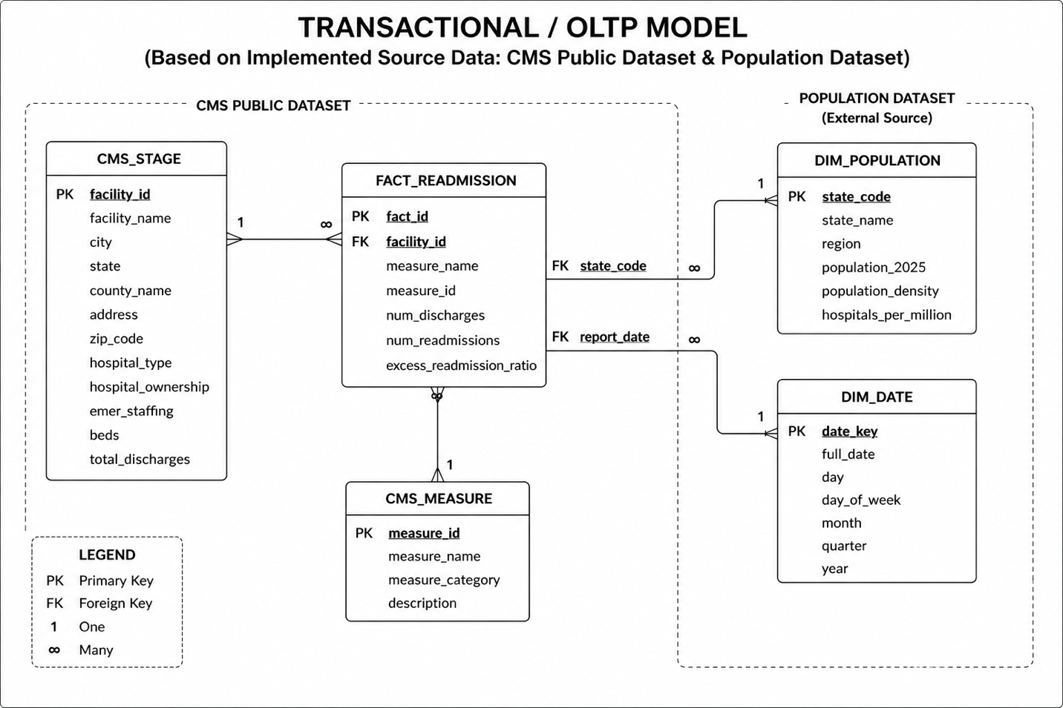
Fig. 4.1 OLTP Model

- Data Warehouse Star Schema
The warehouse was designed using Kimball dimensional modeling principles. A central FACT_READMISSION table stores measurable healthcare events and metrics, while surrounding dimensions provide descriptive business context.

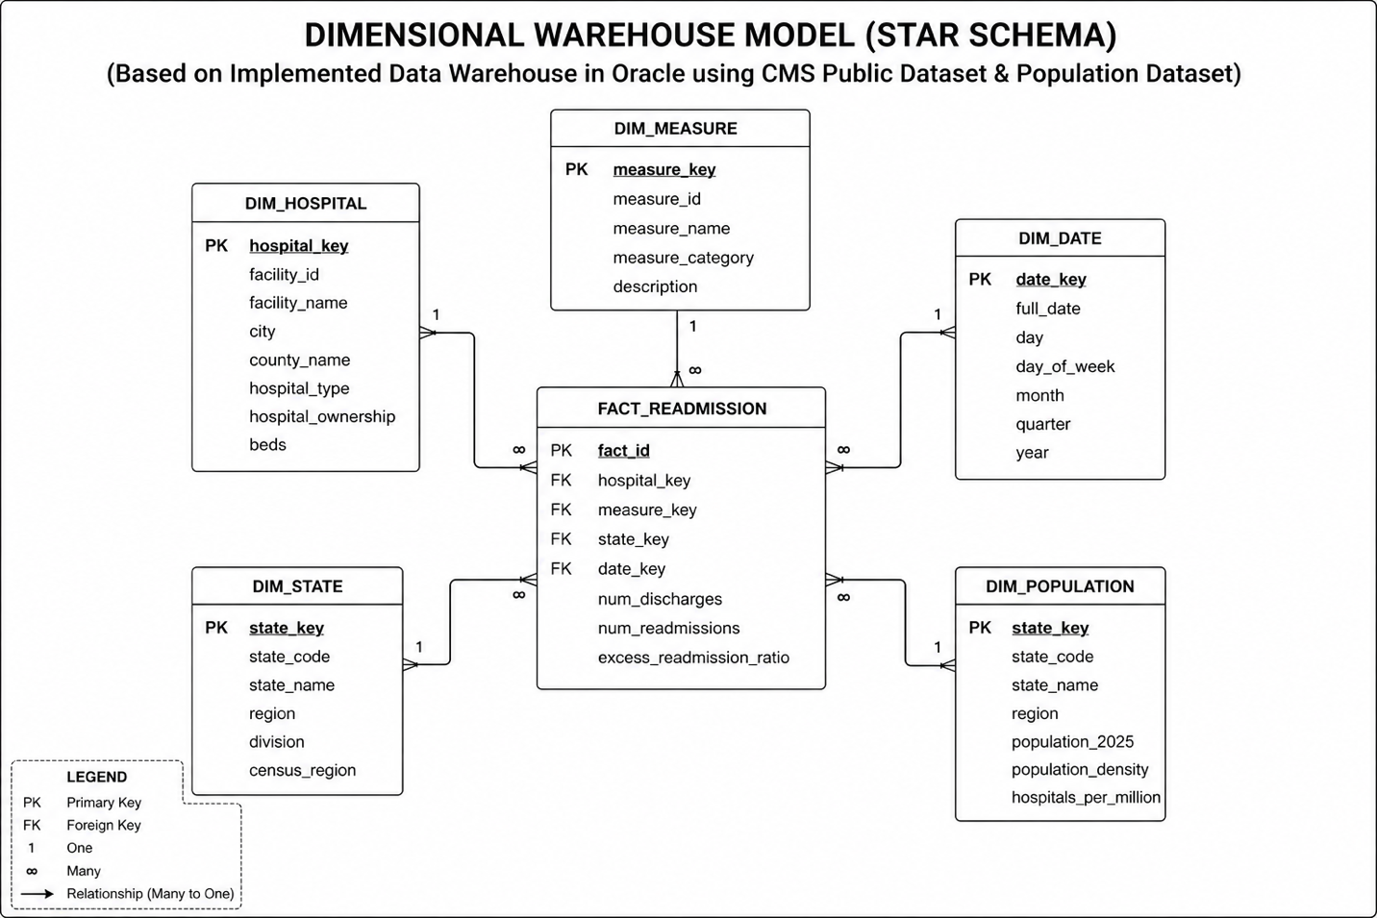
Fig. 4.2 Star Schema

5. ETL Process
A critical component of this project was the design and execution of an ETL (Extract, Transform, Load) pipeline to convert raw public datasets into a structured analytical data warehouse. The source files were not immediately ready for reporting or decision-making. They required cleansing, standardization, validation, and restructuring before being loaded into Oracle.

The ETL process ensured that the final warehouse was reliable, query-efficient, and aligned with dimensional modeling best practices. It also demonstrated how real-world data engineering workflows are used to prepare data for business intelligence systems.

This project used two independent source datasets:
1. CMS Hospital Readmissions Data
2. U.S. State Population Data

These datasets were processed separately during extraction and transformation, then integrated during the loading stage.

5.1 Extract Phase
The first stage of the pipeline focused on retrieving raw source data and staging it for processing.

5.1.1 CMS Dataset Extraction
The CMS hospital readmissions dataset was downloaded in flat-file format from the CMS Provider Data Portal. The raw file contained hospital-level records with performance measures, discharge counts, readmission values, and reporting period dates.

This file was imported into an Oracle staging table named:
CMS_STAGE

The staging table acted as a temporary landing zone where raw data could be inspected before warehouse transformation.

5.1.2 Population Dataset Extraction
The U.S. Census population dataset was obtained in spreadsheet format and converted into a simplified CSV file containing only the fields relevant to the project:
- State Name
- Population 2025

This cleaned file was then imported into Oracle as:
DIM_POPULATION

5.2 Transform Phase
The transformation stage was the most important part of the ETL process. Raw source data contained inconsistencies, mixed data types, and values unsuitable for analytical use.
Multiple cleansing and business-rule transformations were applied.
A. Data Type Standardization
Several numeric fields in the CMS dataset were stored as text because some rows contained values such as:
N/A
Not Available

Fields corrected included:
- Number of Readmissions
- Number of Discharges
- Excess Readmission Ratio
- Predicted Readmission Rate
- Expected Readmission Rate

These fields were converted into numeric formats wherever valid.
B. Invalid Value Filtering
Rows containing unusable text indicators were excluded or conditionally handled in analytical queries.

Examples removed or filtered:
- N/A
- Blank strings
- Non-numeric characters
This prevented SQL errors such as invalid number conversions during aggregation.

C. State Standardization
The CMS dataset stored state values using abbreviations such as:
- FL
- CA
- TX
The population dataset stored state values using full names such as:
- Florida
- California
- Texas
These formats were standardized through mapping logic so that the datasets could be integrated.

D. Duplicate Validation
Hospital identifiers were reviewed to ensure that distinct hospital counts were accurate. Duplicate records caused by multiple measures were expected, but duplicate facility identifiers were carefully handled during aggregation.

E. Date Handling
Reporting period start and end dates were converted into usable date fields for future trend analysis and date dimension expansion.

F. Derived Metrics
Additional metrics were calculated during analysis using transformed data, including:
- Hospitals per 100,000 population
- Readmissions per capita
- State readmission burden
- Average measure risk scores
These derived values increased business relevance beyond raw source fields.

5.3 Load Phase
Once transformation was completed, the cleaned and validated data was loaded into warehouse tables designed for analytics.
FACT_READMISSION
Contained measurable events and metrics such as:
- Number of Readmissions
- Number of Discharges
- Excess Readmission Ratio

Dimension Tables Loaded
DIM_HOSPITAL
DIM_MEASURE
DIM_POPULATION
DIM_DATE (conceptual / expandable)

These dimensions provided descriptive context for slicing and filtering analytics.

5.4 ETL Validation Checks
After loading, several SQL validation checks were performed to confirm data quality.

Examples:
- Total rows loaded
- Distinct hospitals loaded
- Distinct measures loaded
- Null field checks
- Join consistency checks

Example results:
- 18,330 fact records loaded
- 3,055 distinct hospitals loaded
These checks confirmed that the ETL process was successful.

5.5 Challenges Encountered During ETL
Real-world ETL pipelines often involve practical issues. This project encountered and resolved several common challenges:
- Mixed Numeric/Text Fields: Some numeric columns contained text values such as “N/A”, requiring conditional conversion.
- Join Key Mismatch: State abbreviations and full state names needed reconciliation before population joins could succeed.
- Public Dataset Formatting Issues: Source files contained extra columns and reporting fields that required trimming.
- Duplicate Counting Risk: Hospitals appearing under multiple measures required careful use of `COUNT(DISTINCT ...)`.

The ETL process successfully converted raw healthcare and demographic datasets into a clean, integrated Oracle warehouse optimized for analytics. Through extraction, cleansing, standardization, and dimensional loading, the project established a reliable foundation for business intelligence and advanced healthcare decision support.
6. SQL Queries Performed
One of the primary goals of this project was to transform raw healthcare data into actionable intelligence through structured SQL analysis. After the warehouse tables were built and validated, a series of analytical queries were executed to answer operational, strategic, and comparative business questions.

Each query in this section was designed to answer a meaningful business question rather than simply retrieve data. The outputs were later used in dashboard visualizations and executive reporting.

6.1 Number of Hospitals by State
Business Question - Which states have the highest concentration of reporting hospitals?

Understanding the geographic distribution of hospitals helps decision-makers assess infrastructure availability, regional healthcare scale, and market coverage.

SQL Logic
SELECT h.state,
COUNT(DISTINCT f.facility_id) AS hospitals
FROM FACT_READMISSION f
JOIN CMS_STAGE h
ON f.facility_id = h.facility_id
GROUP BY h.state
ORDER BY hospitals DESC;
This query joins the fact table with source hospital location data and counts distinct hospitals by state.
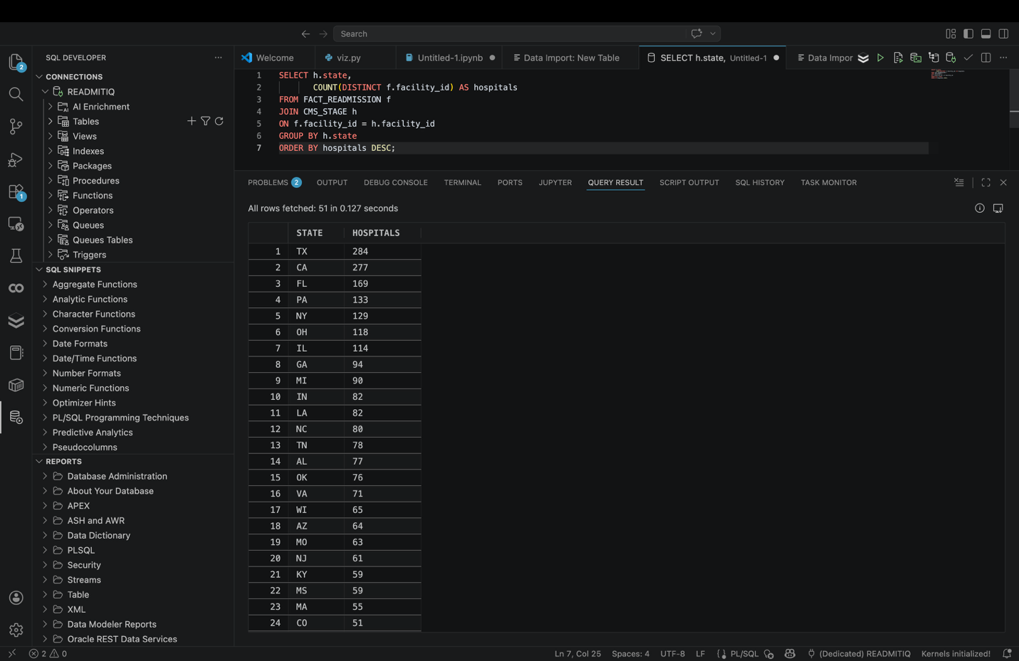
Fig. 6.1.1 Number of Hospitals by State
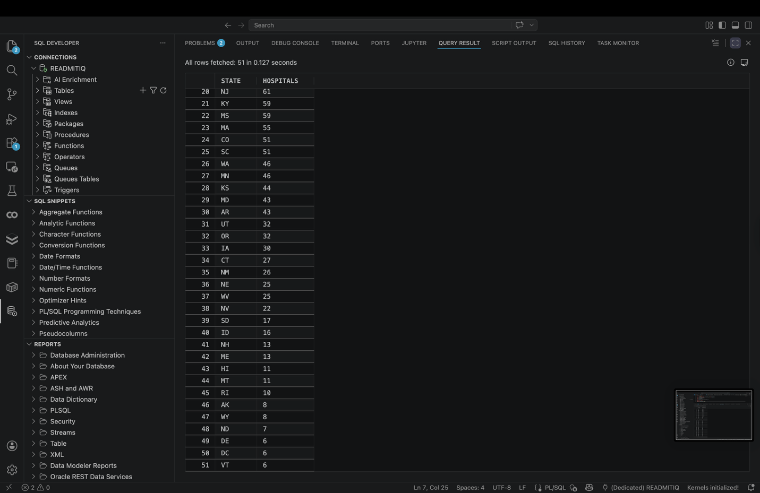
Fig. 6.1.2 Number of Hospitals by State (Cont.)
Key Findings
The highest-ranking states were:
- Texas
- California
- Florida
- New York
- Pennsylvania
Interpretation
Larger states naturally contain more hospitals due to population size and economic scale. However, raw hospital counts alone do not indicate healthcare accessibility. Population-adjusted analysis is required for fair comparisons.
Business Value
This query supports:
- Regional expansion planning
- Healthcare market sizing
- Capacity benchmarking
- Resource allocation analysis
6.2 Total Readmissions by State
Business Question - Which states experience the highest overall readmission burden?

Hospital readmissions create financial and operational pressure. Measuring total readmissions by state helps identify regions requiring quality improvement efforts.

SQL Logic
The query converts numeric text safely, sums total readmissions, and groups by state.
SELECT h.state,
SUM(
CASE
WHEN REGEXP_LIKE(f.number_of_readmissions,'^[0-9]+$')
THEN TO_NUMBER(f.number_of_readmissions)
ELSE 0
END
) AS total_readmissions
FROM FACT_READMISSION f
JOIN CMS_STAGE h
ON f.facility_id = h.facility_id
GROUP BY h.state
ORDER BY total_readmissions DESC;

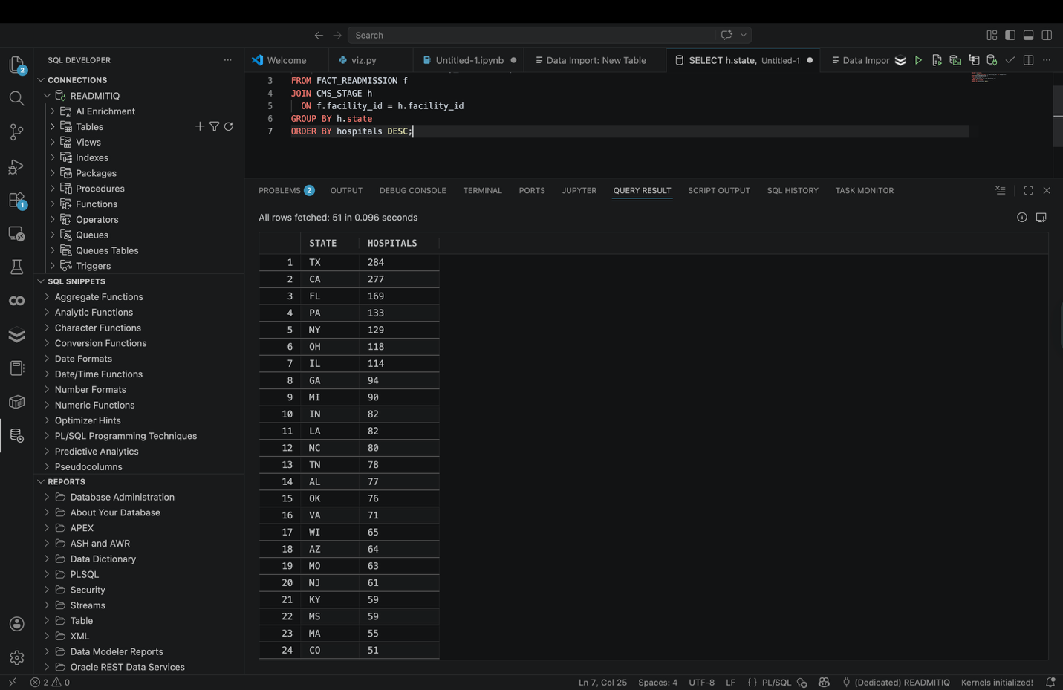
Fig. 6.2 Total Readmissions by State
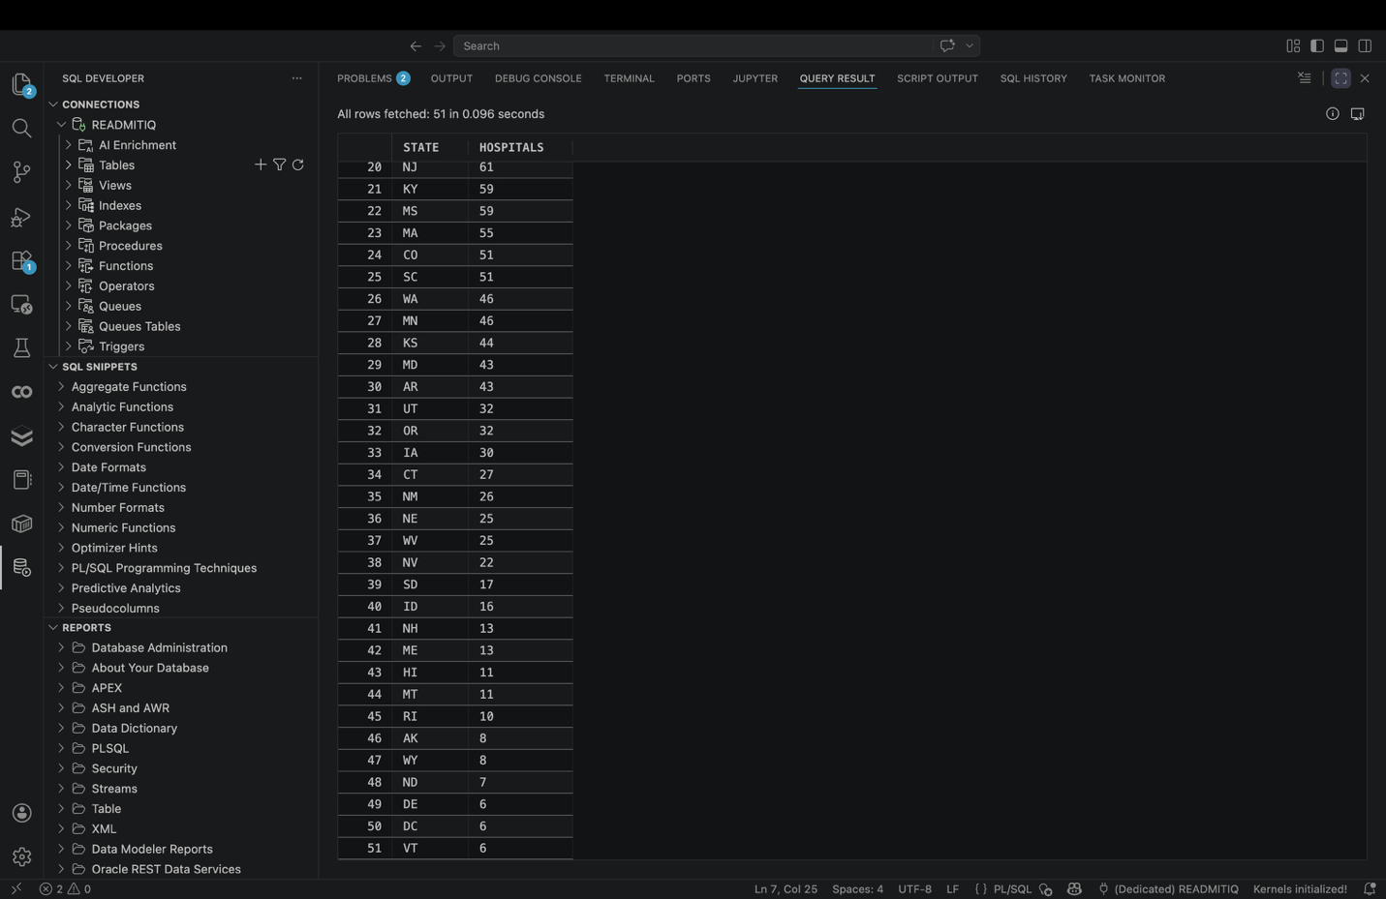
Fig. 6.2.2 Total Readmissions by State
Key Findings
Top states included:
- Florida
- California
- Texas
- New York

Interpretation
States with larger populations and higher patient volumes tend to generate more readmissions. However, elevated readmission totals may also signal discharge planning inefficiencies or chronic care management issues.

Business Value
- State-level intervention prioritization
- Operational burden analysis
- Medicare penalty risk monitoring
- Quality improvement targeting
6.3 Hospitals per 100,000 Population
Business Question - Which states provide the highest hospital availability relative to population?

Raw hospital counts can be misleading. A fairer metric divides hospital count by population.

SQL Logic
Hospital counts were normalized using population estimates.
SELECT h.state,
COUNT(DISTINCT f.facility_id) AS hospitals,
ROUND(COUNT(DISTINCT f.facility_id) * 100000 /
MAX(
CASE h.state
WHEN 'TX' THEN 31376700
WHEN 'CA' THEN 39355300
WHEN 'FL' THEN 23462518
WHEN 'NY' THEN 19571216
ELSE 1000000
END),2) AS hospitals_per_100k
FROM FACT_READMISSION f
JOIN CMS_STAGE h
ON f.facility_id = h.facility_id
GROUP BY h.state
ORDER BY hospitals_per_100k DESC;
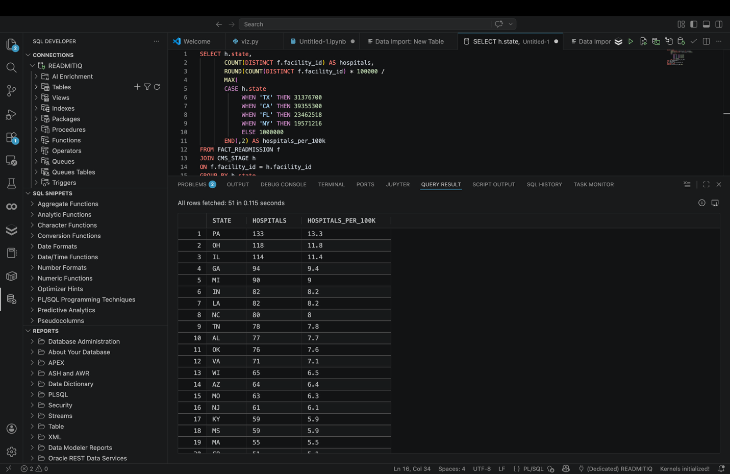
Fig 6.3.1 Hospitals per 100,000 Population
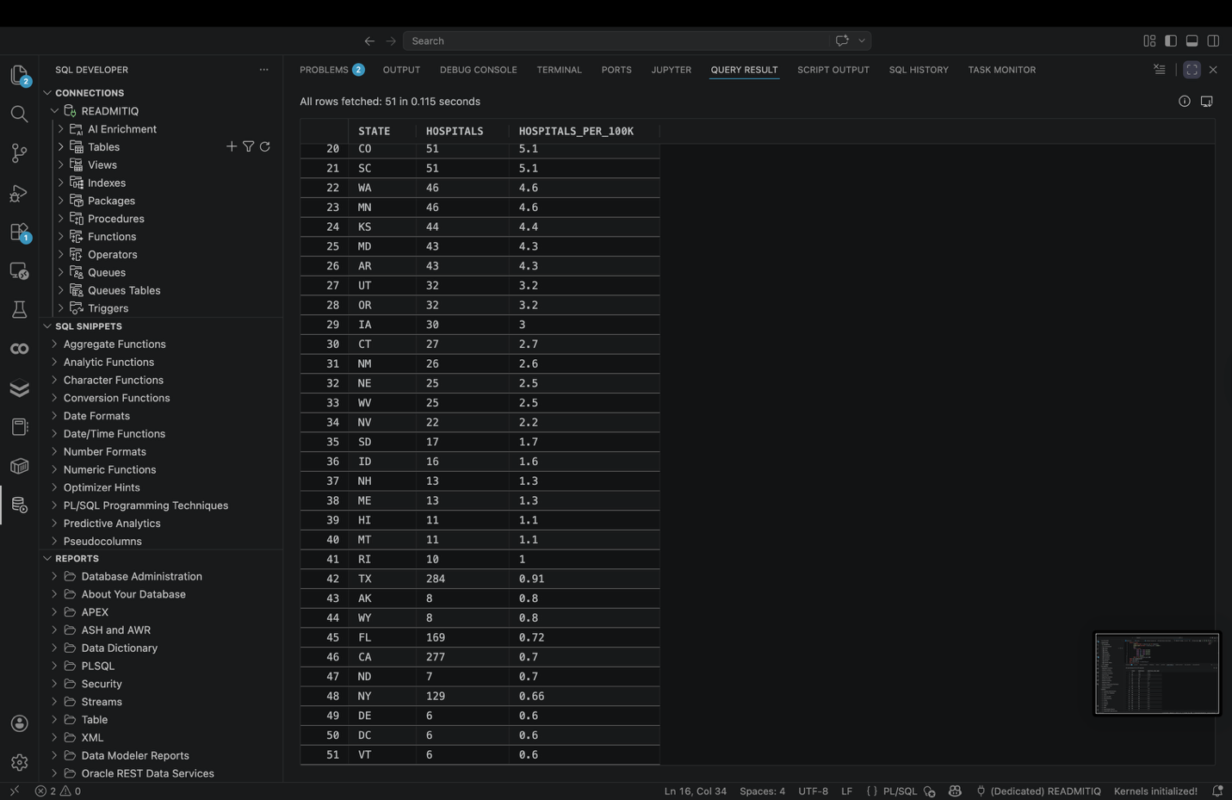
Fig 6.3.2 Hospitals per 100,000 Population (Cont.)
Key Findings
High-ranking states included:
- Indiana
- Louisiana
- Tennessee

Interpretation
Some smaller states outperform larger states when normalized by population, suggesting stronger healthcare facility density and potentially better geographic access.

Business Value
This query supports:
- Healthcare access benchmarking
- Equity analysis
- Infrastructure planning
- Population-adjusted comparisons

6.4 Clinical Measure Risk Comparison
Business Question - Which readmission measures show the highest average excess ratios?

Different medical conditions and procedures carry different readmission risks. This query compares performance across measures.

SQL Logic
Only valid numeric ratio rows were included
SELECT measure_name,
ROUND(AVG(TO_NUMBER(excess_readmission_ratio)),4) AS avg_ratio
FROM FACT_READMISSION
WHERE REGEXP_LIKE(excess_readmission_ratio,'^[0-9.]+$')
GROUP BY measure_name
ORDER BY avg_ratio DESC;

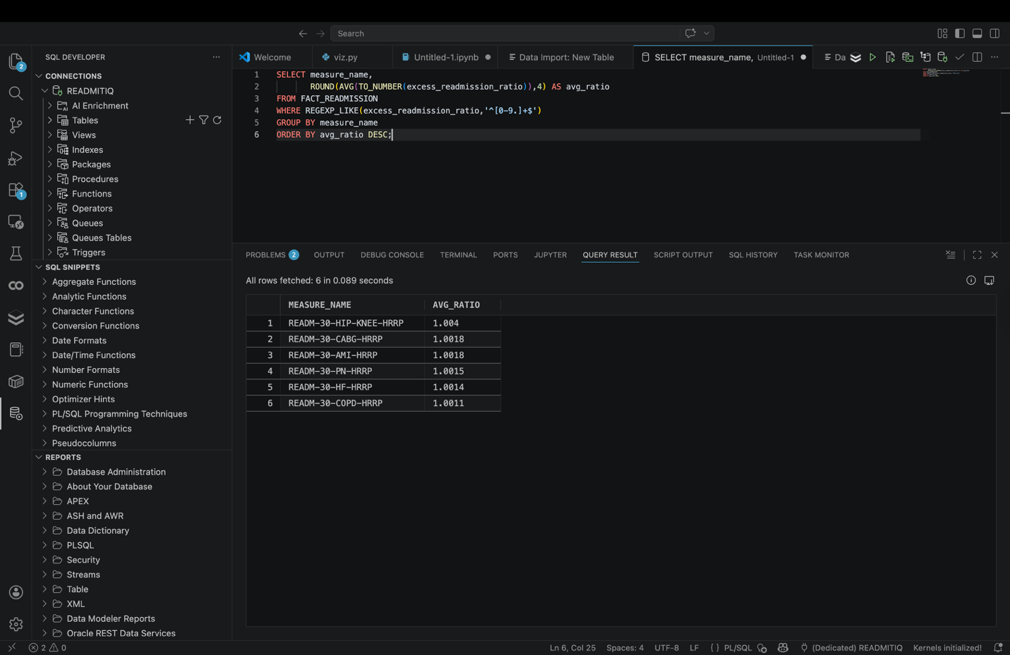
Fig. 6.4.1 Clinical Measure Risk Comparison
Key Findings
Higher-risk measures included:
- AMI (Acute Myocardial Infarction)
- Heart Failure
- CABG-related procedures

Interpretation
Certain conditions consistently generate higher readmission risk due to complexity, patient age, comorbidities, or follow-up care challenges.

Business Value
This query supports:
- Clinical program prioritization
- Risk management
- Care pathway redesign
- Outcome improvement initiatives
6.5 Population-Adjusted Readmission Pressure
Business Question - Which states face the greatest readmission pressure relative to population size?

This combines readmission counts with demographic scale.

SQL Logic
Readmissions are normalized by population.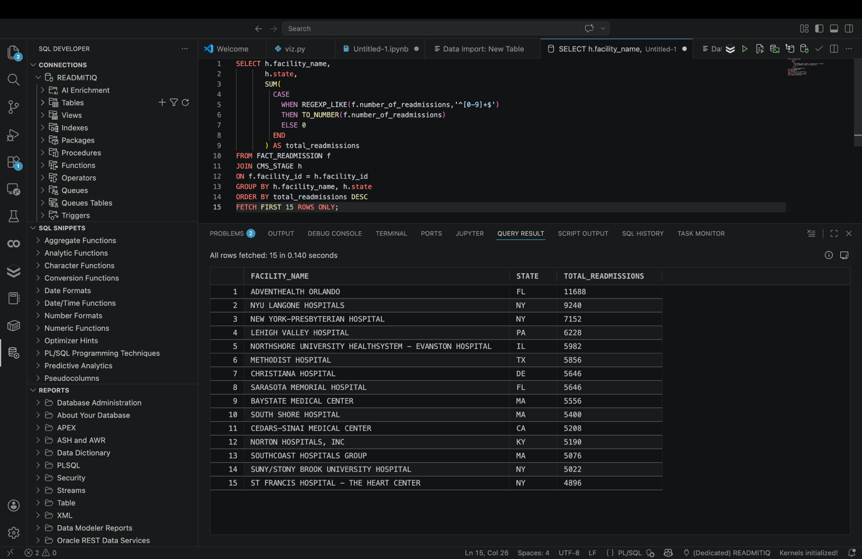
Fig. 6.5.1 Population-Adjusted Readmission Pressure

Interpretation
This metric is more meaningful than raw totals because it highlights healthcare strain relative to the resident population.

Business Value
- Policy prioritization
- Population health planning
- Capacity forecasting
- Regional risk comparison
7. Business Intelligence
A major objective of this project was not only to store and analyze healthcare data, but also to present insights in a clear and actionable format for decision-makers. While SQL queries are essential for backend analytics, many executives, managers, and healthcare administrators rely on visual dashboards to interpret trends quickly and make informed decisions.

To address this need, an interactive Streamlit dashboard was developed as the front-end business intelligence layer of the project. The dashboard connected analytical outputs from the Oracle data warehouse and transformed them into charts, maps, tables, and executive summaries.

This visualization layer made the project more practical by enabling non-technical stakeholders to explore healthcare metrics without writing SQL queries.

7.1 Purpose of the Dashboard
The dashboard was designed to answer the following questions simply and intuitively:
- Which states have the highest hospital readmission burden?
- Which regions have the most hospitals?
- How does healthcare availability differ by population?
- Which measures show elevated readmission risk?
- What trends or outliers require management attention?
Instead of reviewing raw tables, users could interact with visual reports and immediately understand key findings.

7.2 Dashboard Architecture
The visualization workflow followed these steps:
- Data extracted from Oracle warehouse tables
- Analytical SQL outputs converted into structured datasets
- Python scripts processed data into dashboard-ready formats
- Streamlit rendered interactive charts and filters
- End users consumed insights through a browser-based dashboard
This architecture mirrors modern self-service business intelligence systems used in industry.

7.3 Key Dashboard Pages and Visual Components
7.3.1 Executive Summary Dashboard
The Executive Summary page was designed for leadership users who need a quick overview of performance.
Included Metrics:
- Total Hospitals
- Total Readmissions
- Number of States Covered
- Measures Tracked
- Highest Burden States
Provides a one-screen snapshot of healthcare system performance.
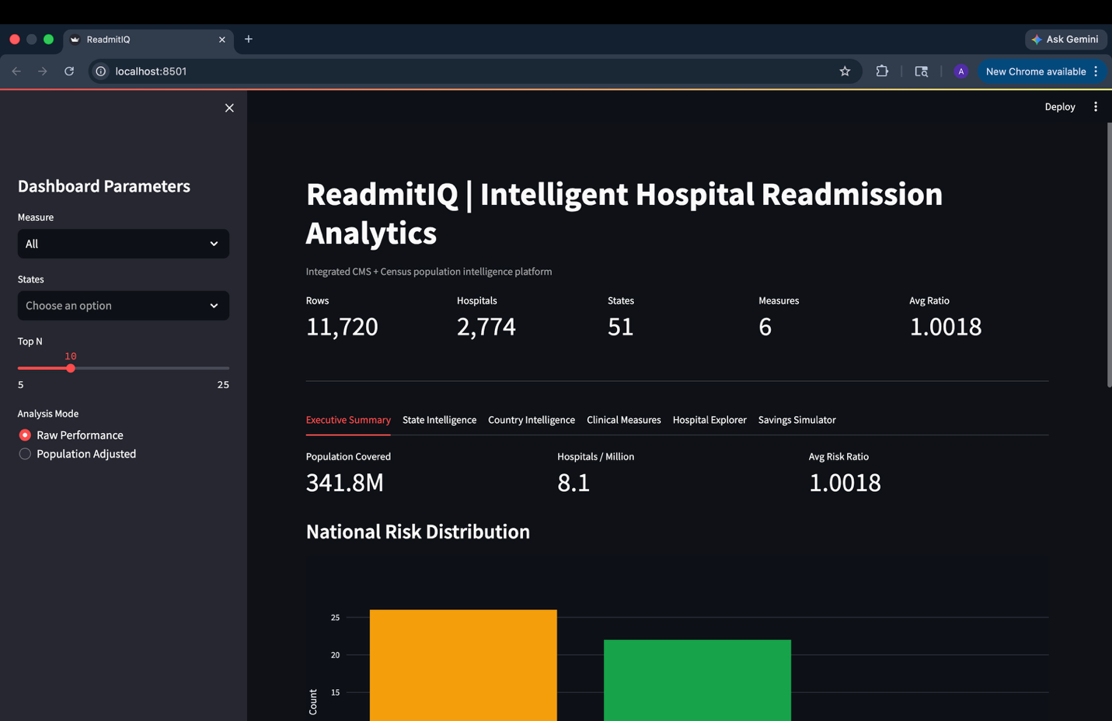
Fig 7.3.1.1 Executive Summary Dashboard
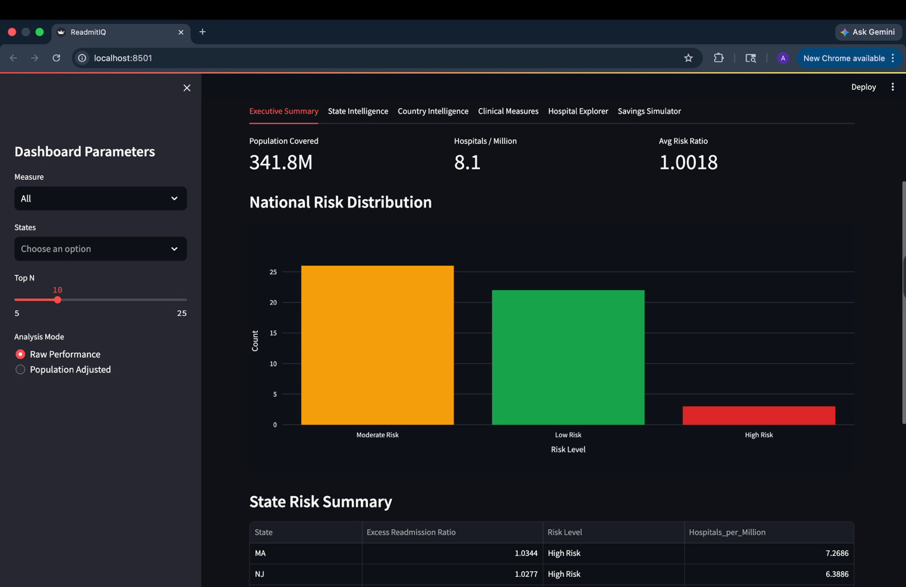
Fig 7.3.1.2 Executive Summary Dashboard (Cont.)
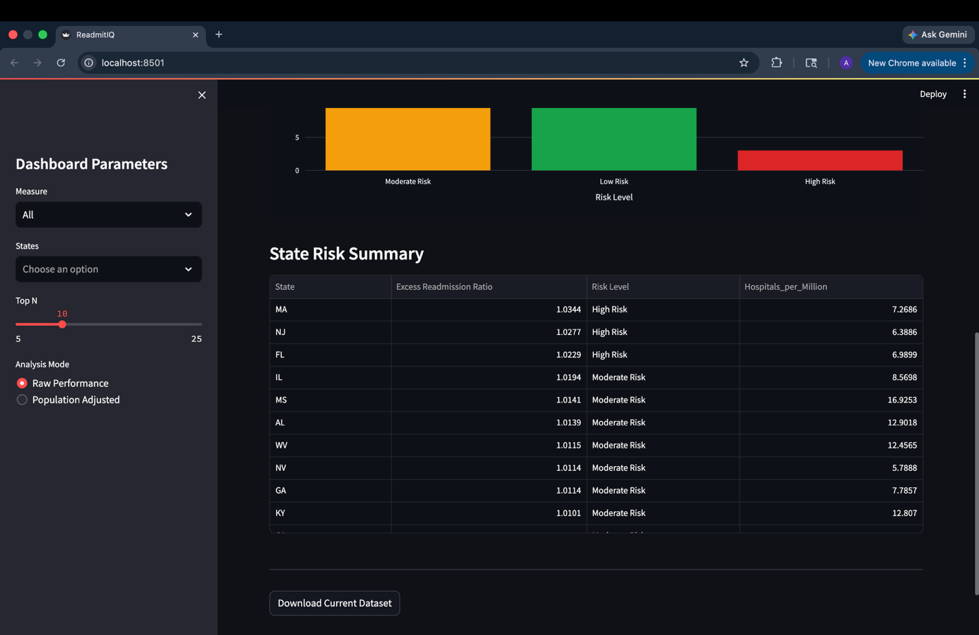
Fig 7.3.1.3 Executive Summary Dashboard (Cont.)

7.3.2 State Intelligence Dashboard
Allows administrators to compare states and identify overburdened or underserved markets.
Included Visuals:
- Hospitals by State Bar Chart
- Readmissions by State Ranking
- Top and Bottom State Comparisons
- Population-adjusted hospital density
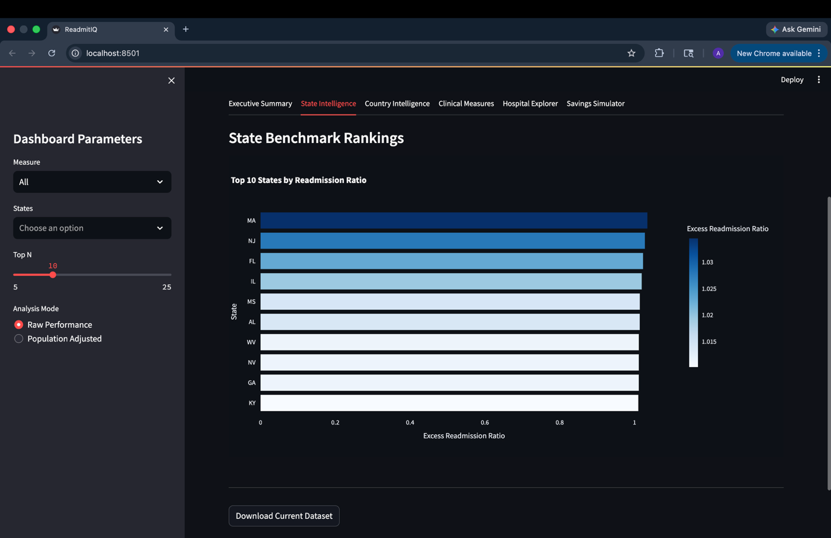
Fig. 7.3.2.1State Intelligence

7.3.3 Country Intelligence / U.S. Map Dashboard
A geographic map was developed to visualize readmission burden or hospital density across the United States. Maps make geographic disparities easier to understand than raw tables.
Included Visuals:
- Color-coded state map
- Interactive hover metrics
- State-level comparisons
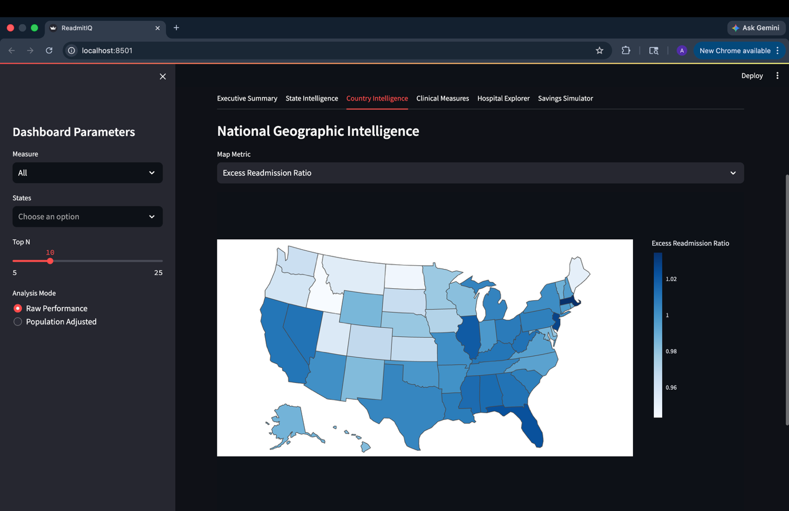
Fig. 7.3.3.1 National Geographic Intelligence

7.3.4 Clinical Measure Performance
This section compares readmission performance across clinical conditions. Helps healthcare leaders identify which care programs require immediate attention.
Included Visuals:
- Average Excess Readmission Ratio by Measure
- Risk Ranking Charts
- Measure-specific filters
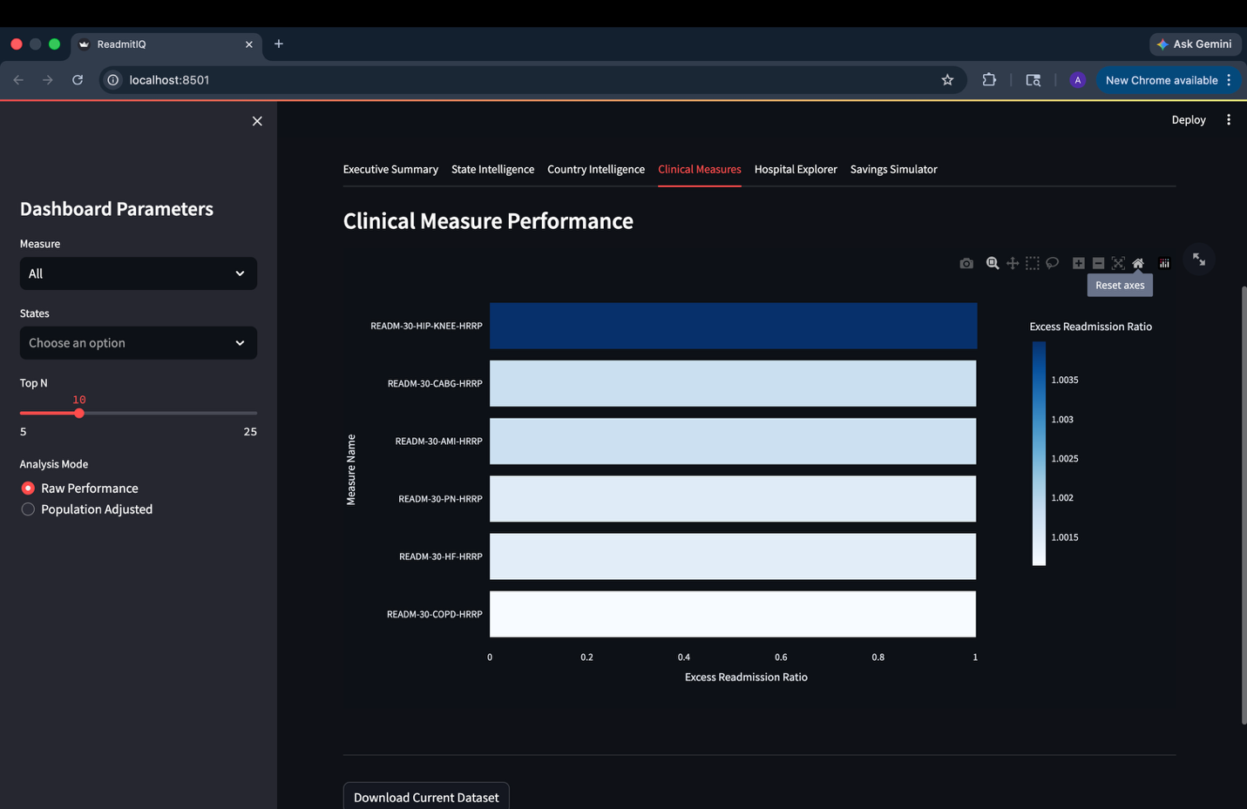
Fig. 7.3.4.1 Clinical Measure Performance
7.3.5 Hospital Exploration
This chart compares hospital volume and readmission performance. Highlights outlier hospitals with poor outcomes despite high volume.
Example Metrics:
- X-axis: Number of Discharges
- Y-axis: Excess Readmission Ratio
- Bubble Size: Readmissions
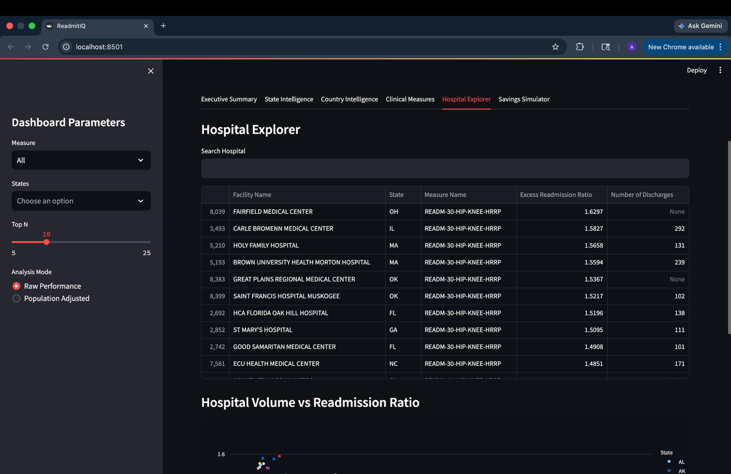Fig. 7.3.5.1 Hospital Exploration
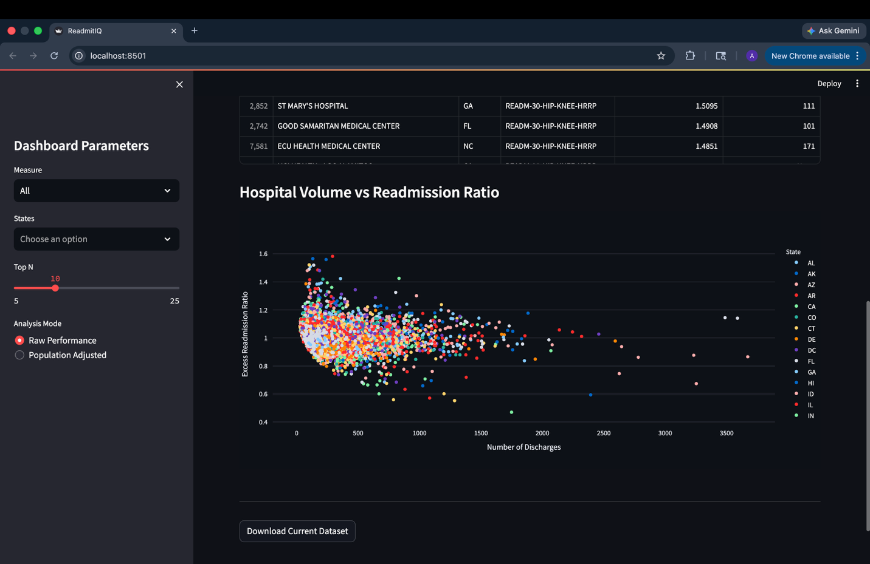
Fig. 7.3.5.2 Hospital Exploration (Cont.)

7.3.6 Savings Simulator Dashboard
This dashboard estimates potential cost savings from reducing hospital readmission rates through interactive scenario analysis. Helps healthcare leaders evaluate the financial impact of readmission reduction strategies and supports data-driven investment decisions.
Included Visuals:
- Reduction Percentage Slider
- Projected Savings KPI
- Monthly Savings Trend Line
- State and Measure Filters
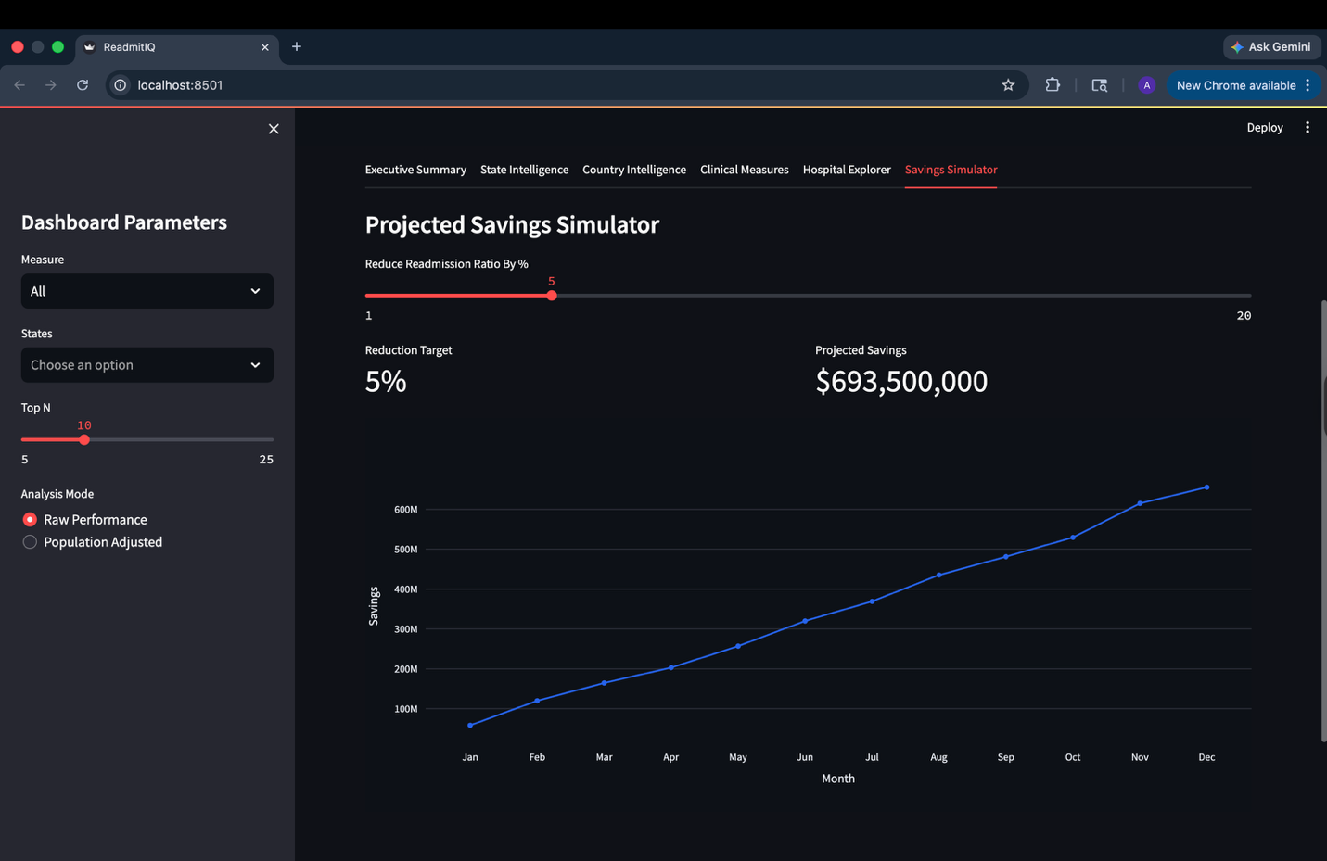
Fig. 7.3.6.1 Savings Simulator Dashboard

7.4 Dashboard Parameters and Filters
The Streamlit dashboard was designed with interactive filters to help users customize analysis and explore insights dynamically instead of relying on static reports. These filters improved usability by allowing decision-makers to compare regions, focus on specific measures, rank performance, and run scenario analysis in real time.

Measure Filter
Allows users to select specific clinical measures, such as AMI, Heart Failure, Pneumonia, or view all measures together.

State Filter
Enables state-level analysis by selecting one or multiple U.S. states.

Top N Filter
Controls how many top states or hospitals appear in charts (Top 5, Top 10, etc.).

Analysis Mode Toggle
Users can switch between:
- Raw Performance – total hospitals, readmissions, discharges
- Population Adjusted – hospitals or readmissions relative to population

Reduction Target Slider
Used in the Savings Simulator to estimate projected cost savings based on selected readmission reduction percentages.
8. Technologies Used
A modern analytics solution requires multiple technologies working together across data storage, processing, analysis, and visualization layers. This project was designed as an end-to-end healthcare intelligence platform using industry-relevant tools that simulate real-world data engineering and business intelligence environments.

Each technology was selected based on scalability, usability, and its role within the overall architecture.

8.1 Oracle Database / Oracle SQL
Oracle Database was used as the core data warehouse platform for storing structured healthcare data. It served as the central repository for staging tables, fact tables, and dimension tables.

Oracle SQL was used to perform:
- Table creation and schema design
- Data loading and transformation
- Aggregation queries
- Analytical reporting
- Multi-table joins
- Population-adjusted calculations
Oracle was selected because it is widely used in enterprise environments and provides strong support for data warehousing workloads.

8.2 Python
Python was used as the orchestration and analytics language for handling external datasets and dashboard logic.

Python was used for:
- Data cleaning
- CSV preprocessing
- Population dataset formatting
- Query result processing
- KPI calculations
- Streamlit dashboard scripting

Python was chosen because it is one of the most widely used languages in analytics, machine learning, and data engineering.

8.3 Pandas
Pandas was used as the primary data manipulation library within Python.

It enabled:
- Reading CSV datasets
- Cleaning null values
- Renaming columns
- Data type conversions
- Filtering records
- Preparing datasets for visualization

Pandas significantly reduced preprocessing time and simplified integration between CMS and population datasets.

8.4 Streamlit
Streamlit was used to develop the interactive front-end dashboard.

It provided:
- Fast web app deployment
- KPI cards
- Filters and dropdown menus
- Interactive charts
- Multi-page dashboard navigation
- Real-time scenario simulation

Streamlit was selected because it allows rapid creation of professional analytics dashboards using only Python.

8.5 Plotly
Plotly was used for interactive charting and advanced visualization. Charts like bar charts, line charts, scatter plots, geographic maps, and trend analysis visuals were included. Plotly improved the dashboard experience by allowing zooming, hovering, filtering, and dynamic chart interaction.

8.6 Visual Studio Code
VS Code was used as the primary development environment. Its extensions made Oracle and Python integration efficient during development.

It supported:
- SQL development
- Python scripting
- Streamlit execution
- Project organization
- Version-controlled coding workflow

9. Challenges Faced
Several practical challenges were encountered during the development of this project, reflecting common issues found in real-world data analytics environments. One of the primary challenges involved data quality problems within the CMS dataset. Some numeric columns contained text values such as “N/A”, blanks, or inconsistent formats, which created SQL errors during calculations and aggregations. These issues were resolved through data cleaning, filtering, and conditional numeric conversion techniques.

Another major challenge was integrating multiple datasets with different formats. The CMS dataset used two-letter state abbreviations such as FL, TX, and CA, while the population dataset used full state names such as Florida, Texas, and California. Because of this mismatch, joins initially failed and required transformation logic to standardize values before successful integration could occur.

The project also required careful handling of duplicate counting and schema design. Hospitals appeared multiple times because each facility reported across several clinical measures. To avoid overstating results, distinct counting methods were used. In addition, the raw flat files had to be redesigned into a dimensional warehouse structure with fact and dimension tables to improve scalability and reporting efficiency.

Finally, dashboard development introduced challenges related to usability and presentation. The visualizations needed to remain informative while avoiding clutter. Filters, layouts, and chart types were refined to ensure that both technical and non-technical users could easily interpret the results. Overcoming these challenges strengthened the final solution and demonstrated practical skills in ETL processing, SQL troubleshooting, dimensional modeling, and business intelligence development.
10. Future Enhancements
While the current project provides a strong analytical foundation, several future enhancements could make the platform more advanced and business ready. One potential improvement would be the implementation of automated ETL pipelines that periodically collect, clean, and load updated CMS datasets into the warehouse. This would reduce manual effort and ensure that reports remain current over time.

Another enhancement would be the addition of time-series and trend analysis. By storing multiple years of hospital data, the warehouse could track changes in readmission rates over time, identify seasonal patterns, and compare pre- and post-policy performance across regions. This would significantly improve long-term strategic planning capabilities.

The platform could also be expanded through benchmarking and scorecard features. Hospitals could be ranked against state and national averages, allowing administrators to compare performance against peers. Scorecards could highlight top-performing facilities as well as hospitals requiring quality improvement attention.

Finally, the visualization layer could be upgraded with mobile-friendly dashboards, executive KPI summaries, and alert systems. Automated notifications could be triggered when readmission rates exceed thresholds or when unusual trends appear. These features would improve accessibility and help decision-makers respond more quickly to emerging healthcare issues.
11. Conclusion
This project successfully demonstrated how raw public healthcare data can be transformed into a structured and decision-ready analytics platform using data warehousing principles. By integrating CMS hospital readmission data with U.S. population data, the solution moved beyond simple reporting and enabled deeper performance comparisons, capacity analysis, and population-adjusted healthcare insights.

Using Oracle SQL, the project implemented a dimensional warehouse architecture consisting of fact and dimension tables optimized for analytical querying. ETL processes were used to clean inconsistent source data, standardize formats, and load reliable records into the warehouse. A series of SQL queries then generated meaningful business intelligence related to hospital distribution, readmission burden, infrastructure density, and clinical risk measures.

The addition of an interactive Streamlit dashboard further strengthened the solution by converting backend analytics into accessible visual reports for decision-makers. Rather than relying only on SQL outputs, stakeholders could explore trends, compare states, and simulate cost-saving opportunities through a user-friendly interface.

Overall, this project demonstrates practical skills in data warehousing, SQL analytics, ETL engineering, and business intelligence development. It also highlights how modern analytics systems can support healthcare organizations in improving operational efficiency, reducing readmissions, and making more informed strategic decisions.

